AWS EC2 Task

STEP : Open AWS console and go to EC2.

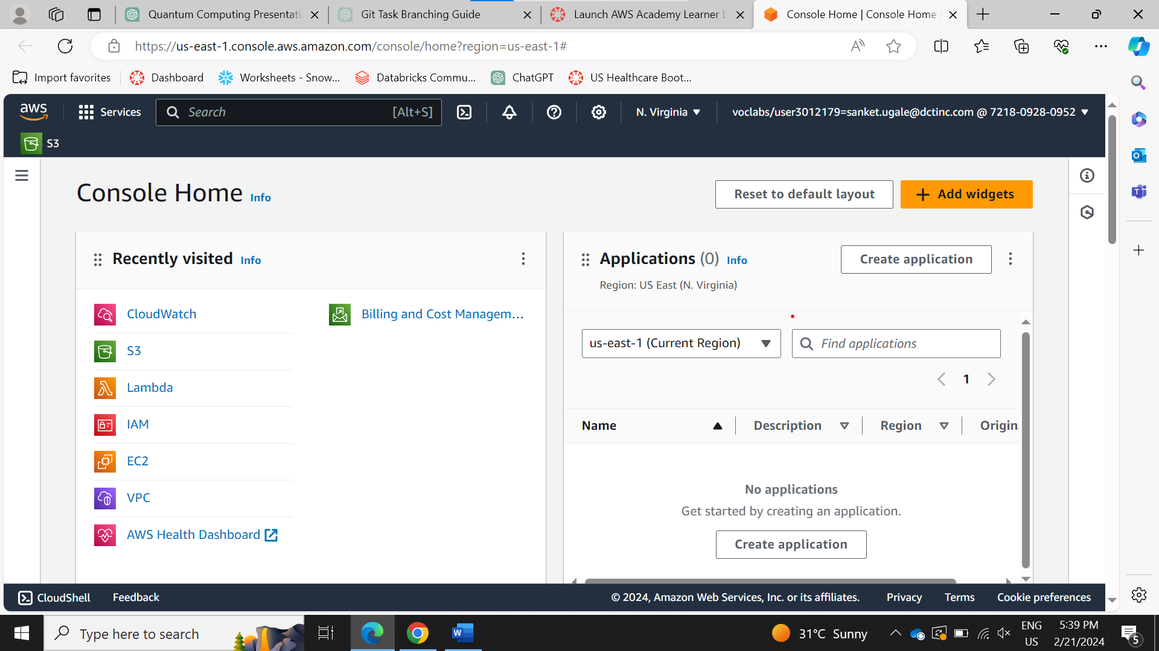

STEP : Click on Instance

STEP : Click on Launch Instances

STEP : Give a name to your instance and select the AMI (Amazon Machine Image)

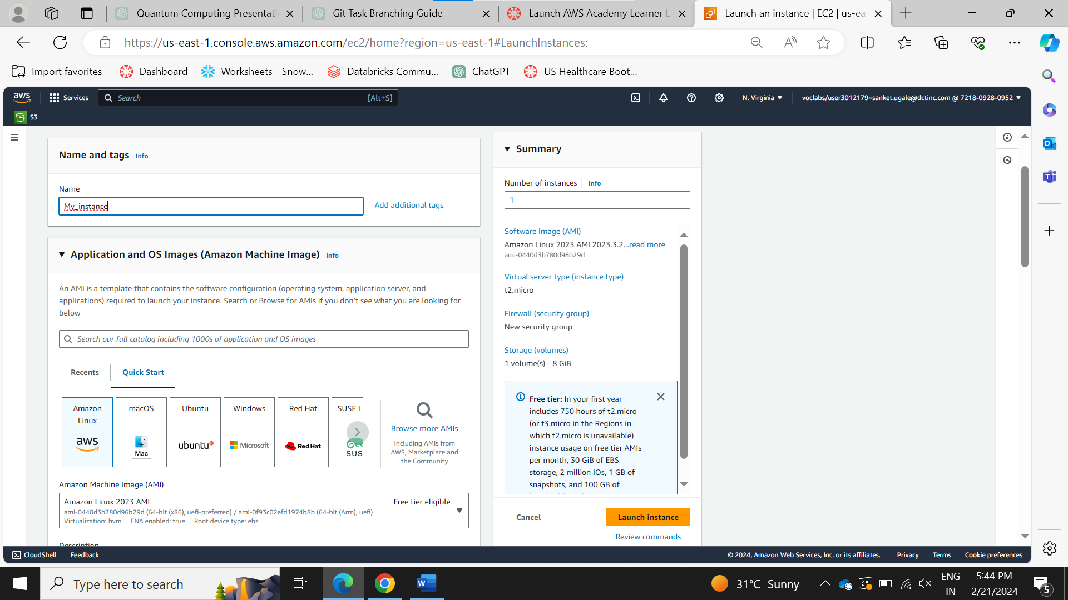

STEP : Select your instance type from the drop down menu and click on the create key pair.

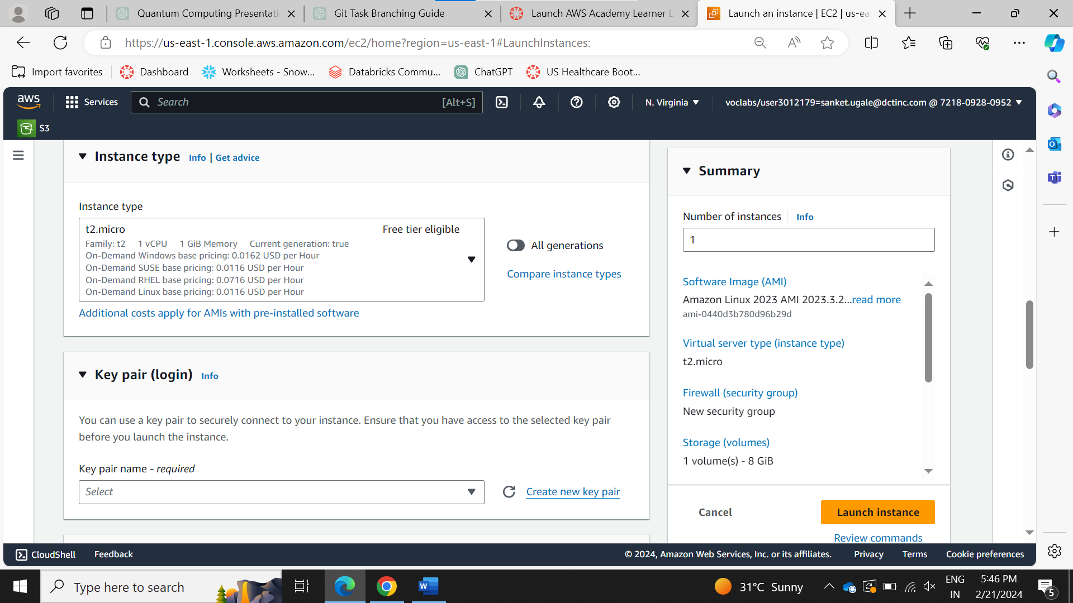

STEP : Name your key pair and select the .pem and click on create key pair and download the key pair.

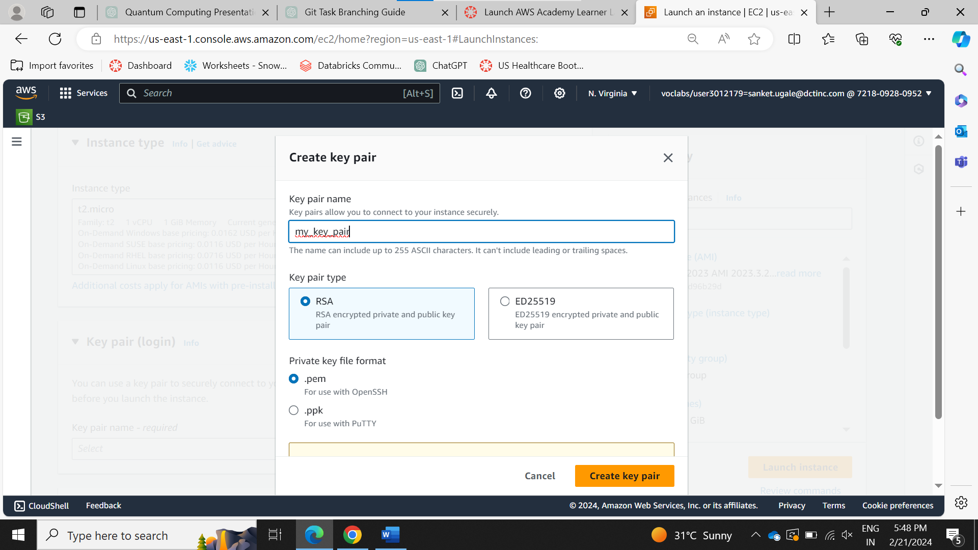

STEP : tick the create security group and create instance.

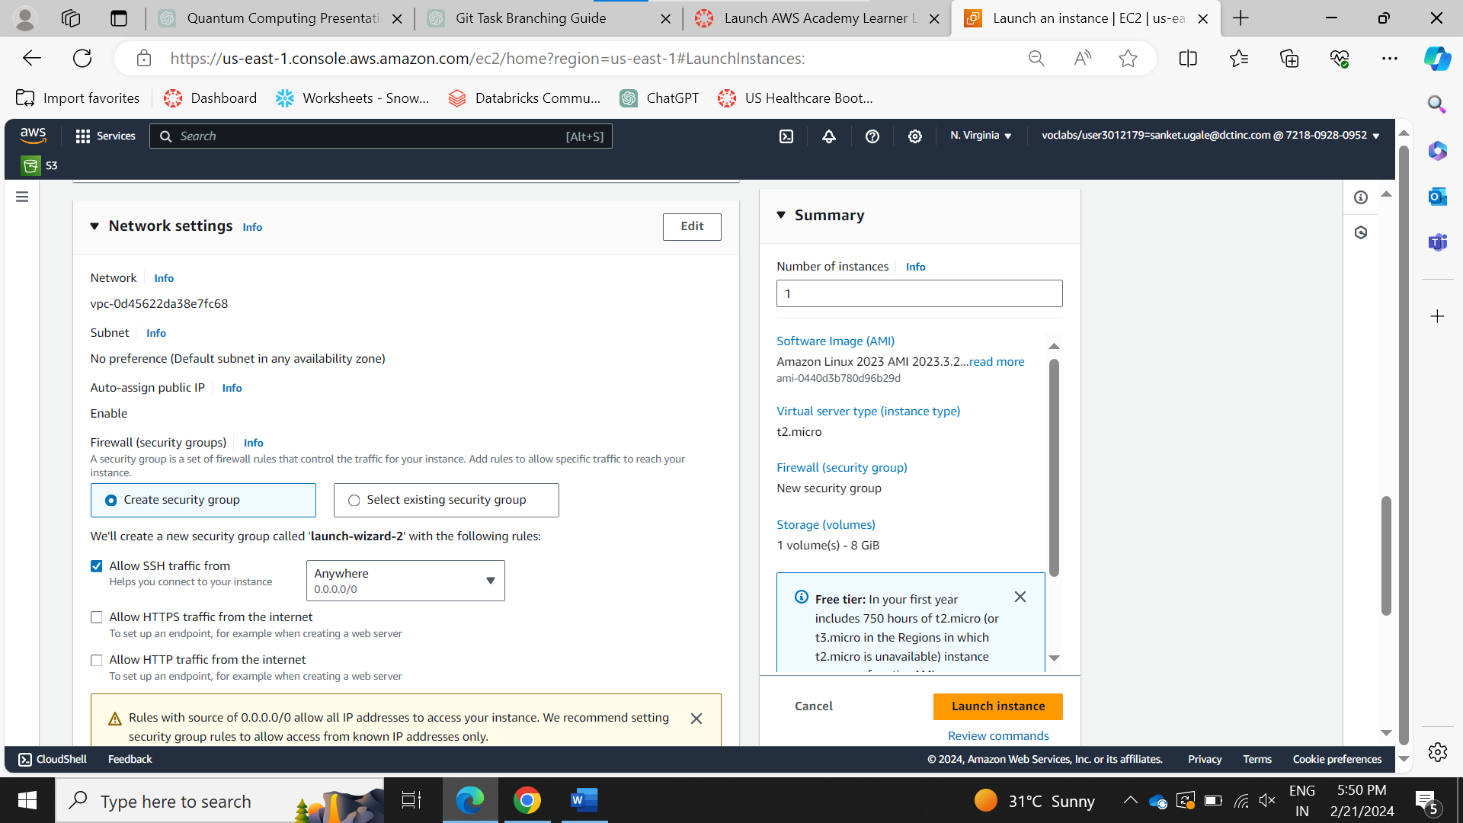

STEP : again go to instacnes and wait until you instance states comes to “Running”

STEP : Go to Elastic IP in network and setting and click on allocate elastic IP.

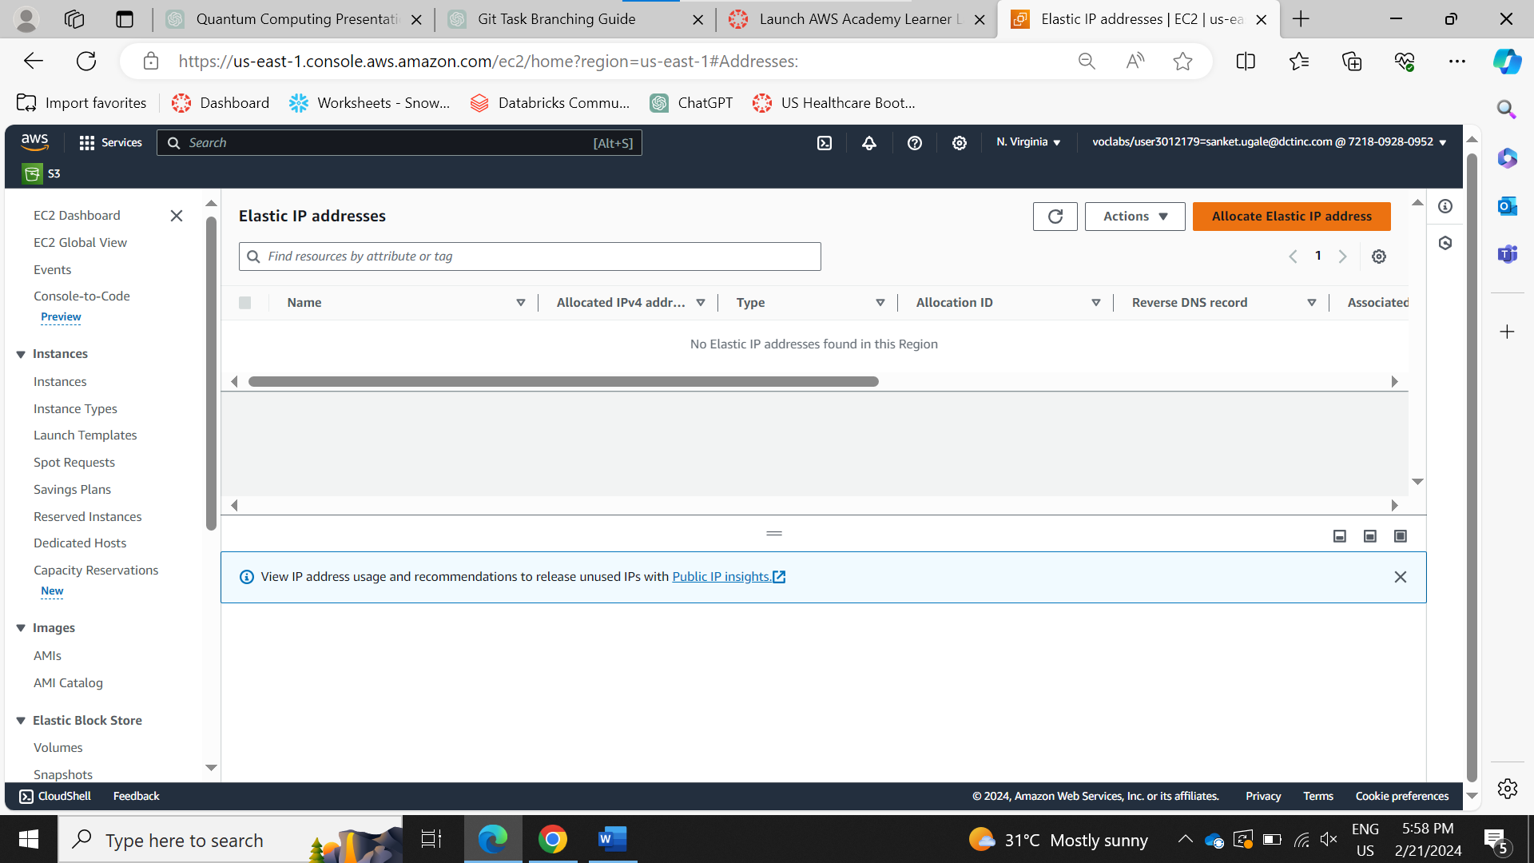

STEP : Click on allocate.

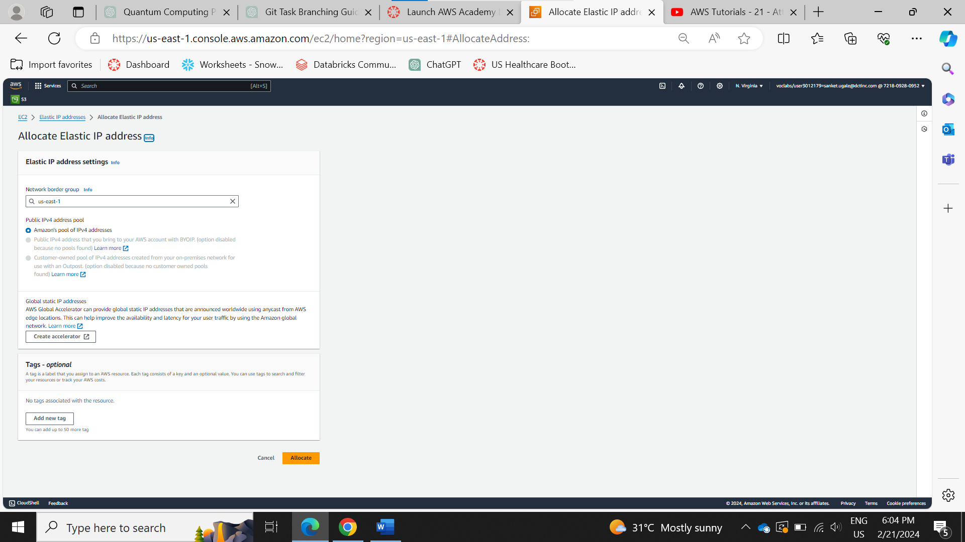

STEP : Your Elastic IP is generated rename it as per your need.

STEP : Select your Elastic IP and click on Actions and click on Associate Elastic IP Address.

STEP : Tick the instance and select your instance from drop down menu and click on associate.

STEP : Congratulations your Elastic IP address is associated with your instance.

STEP : Now go to instances select your instance and click on connect.

STEP : Go to SSH Client. And Copy your Public DNS.

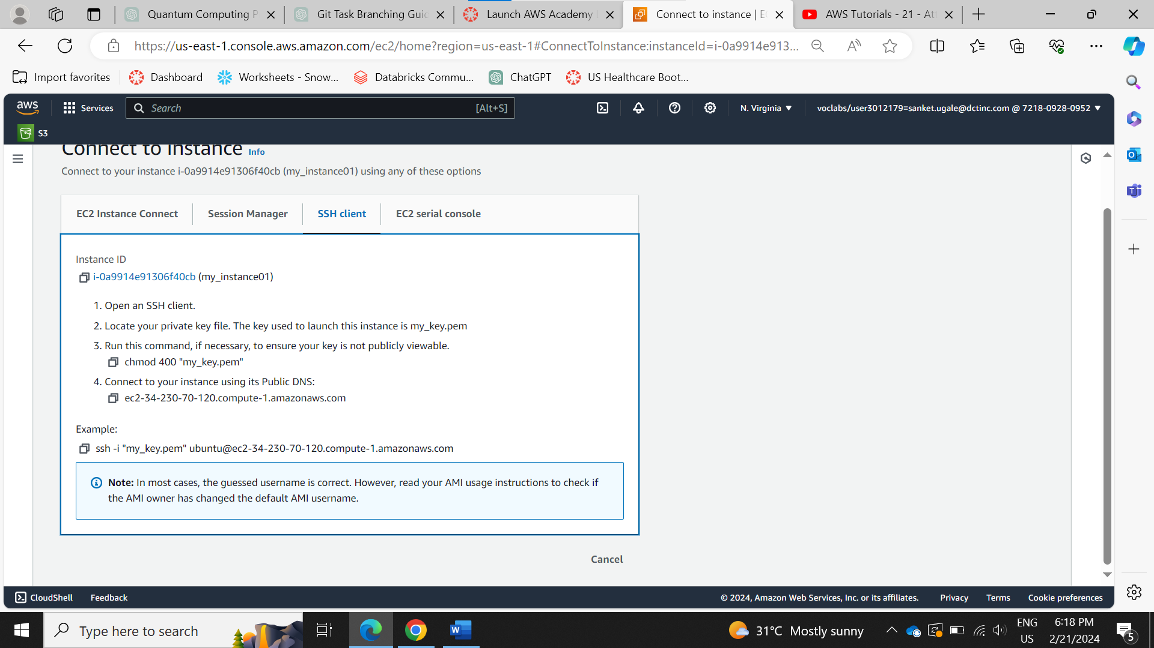

STEP : Open Command Prompt and Go to location where your key pair is downloaded.

And type the “ssh -i "my_key_pair.pem" [ec2-user@ec2-3-88-125-44.compute-1.amazonaws.com](mailto:ec2-user@ec2-3-88-125-44.compute-1.amazonaws.com)” and click enter.

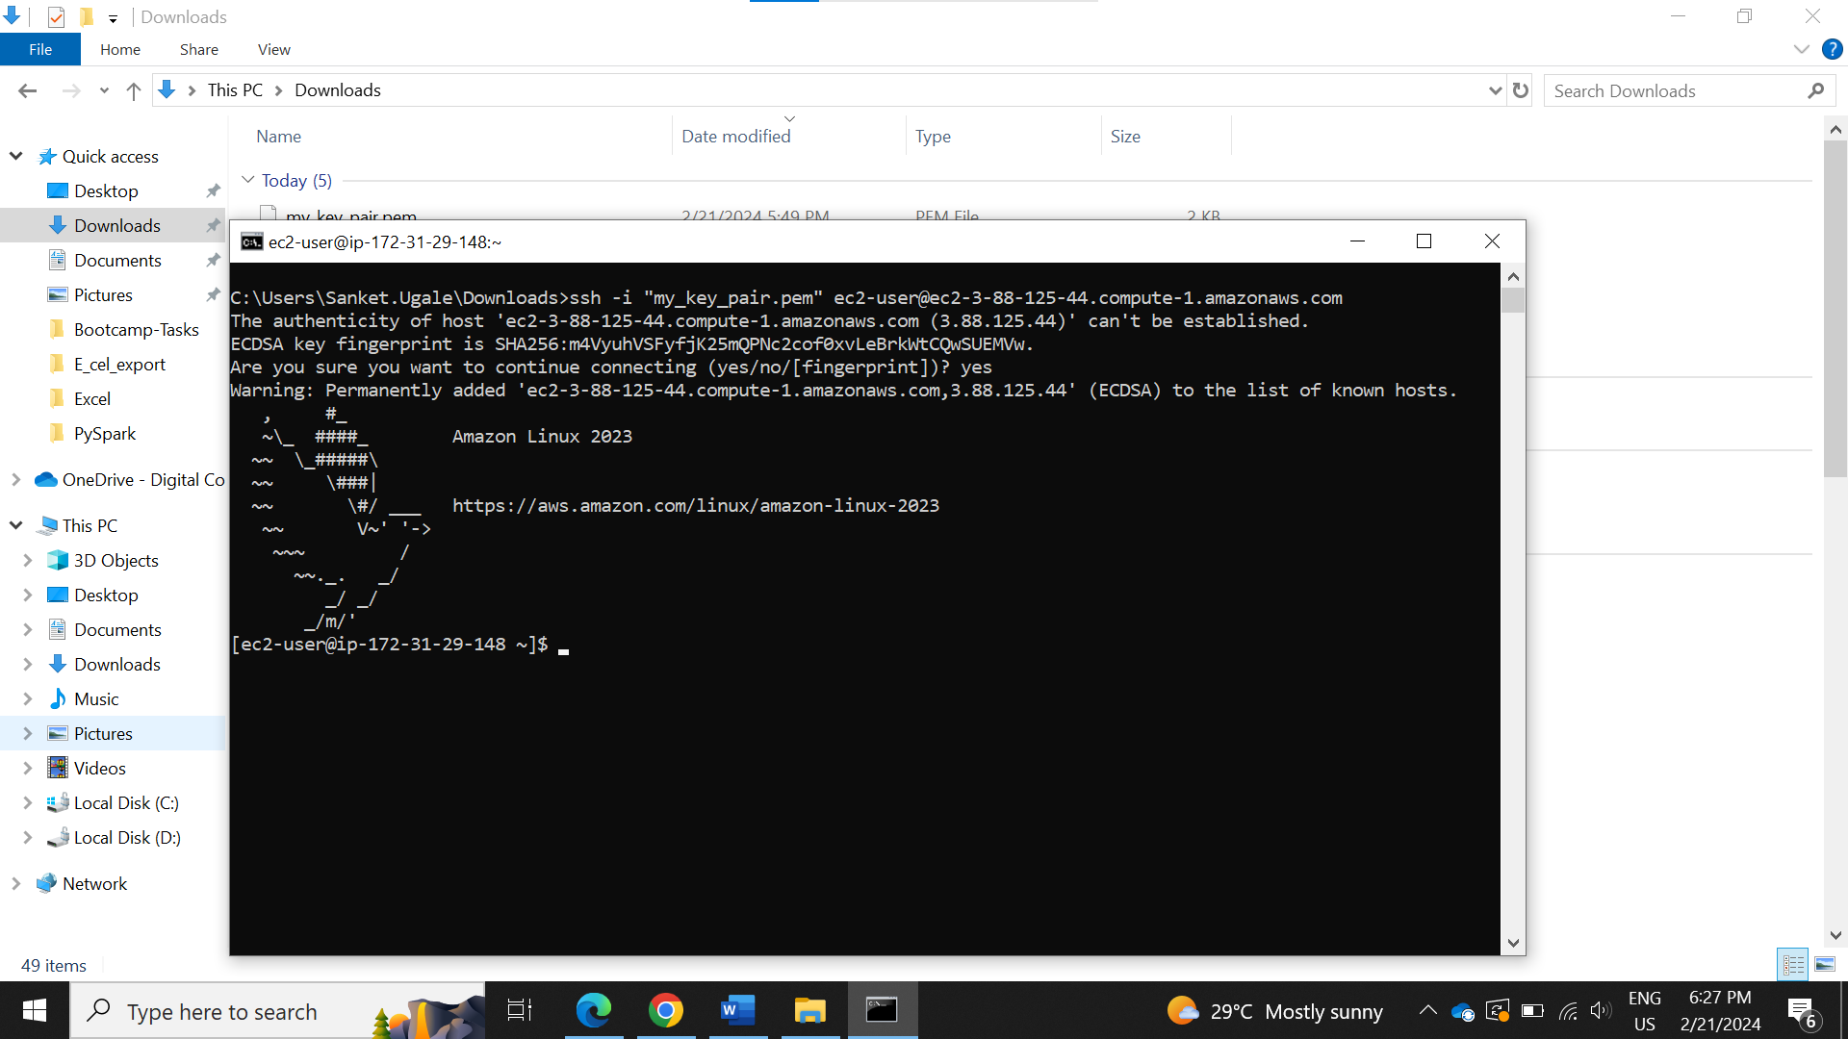”

STEP : Congratulations you are connected to your EC2 instance by using ssh

AWS S3 Task